Demo Walkthrough with Intelligent Support
(based on sample student actions)

- First, please watch the tutorial and make the flower model step by step. The rest of the walkthrough assumes you are familiar with the basic features or eXpresser.
  - http://lkl.ac.uk/projects/migen/?q=node/23

- Start eXpresser and select the “TrainTrack” activity. Follow Laura’s activity

- Laura has in mind the following structure for making the TrainTrack model.



Step 1 - She starts making the red pattern. She uses two red tiles as shown below, makes a building block, and then a pattern: 2 , 0 , 6 .  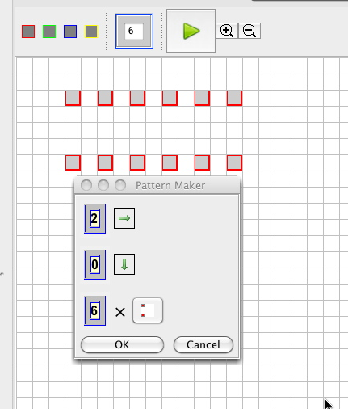 | Step 2 - She then immediately (ignoring any help that may appear) colours her pattern by counting the tiles in the construction area. She puts 12 for the number of red tiles   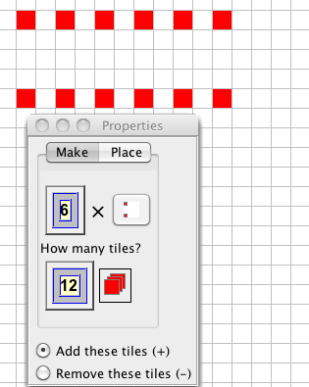
Step 3 – Looking at the goals and the animated task presentation, she appreciates and remembers from previous interactions that she has to animate the pattern. She clicks ‘play’, and receives the prompt: “There are no unlocked numbers”.   | Step 4 - She unlocks the 6 (repetitions of her building block) and tries to animate again.    The pattern does not stay coloured, it ‘messes’ up. She pauses the animation and sets the value of the unlocked number back to 6.

 The Intelligent Support box lights up and Laura clicks and gets:
“Your pattern might not be coloured for a different number of building blocks.”

Step 5 - Laura edits the number of repetitions to 3 and thinks that she has to change the number used in the colouring and thus unlocks it and changes it to 6  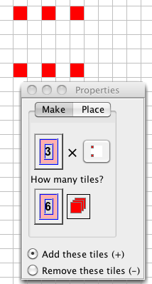 | The Intelligent Support box lights up and Laura clicks and she gets:  “How did you find the correct number of tiles?”

Step 6 - Laura realises that to find the number of tiles she was multiplying the number of repetitions of the building block by the number of tiles in the building block, so (knowing how to build expressions from previous tasks) she builds an expression .  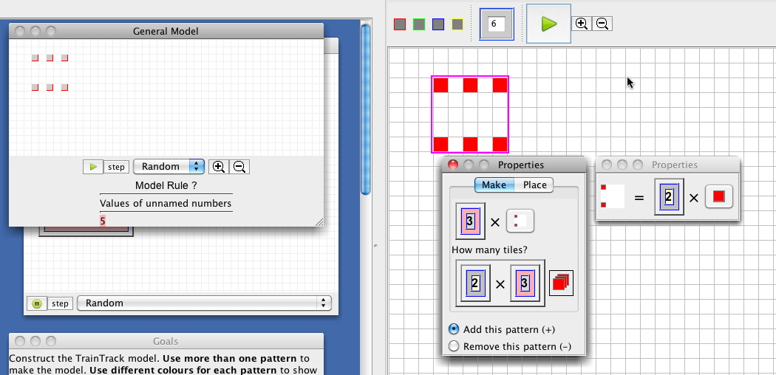 | Step 7 - Now she tries animating her pattern and it does not mess up.
Step 8 - So she starts building the blue pattern (and placing it appropriately to look like the TrainTrack)
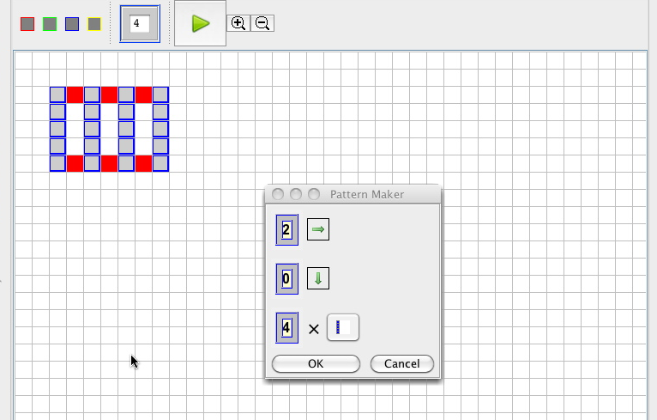
Step 9 – Her experience at Step 6 helps here. She first unlocks the number 4 and colours the pattern making the expression 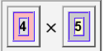.  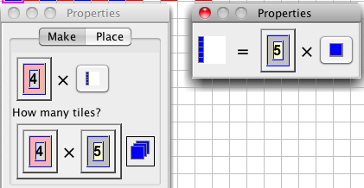 | She clicks play and the model is messed-up again (this time as far as its structure is concerned).  She repairs it again trying to see what’s going on. She notices the available help and clicks to get the following prompt.  “The General Model is messed-up.”  and another message:  “Would your model be messed-up if you changed this unlocked number?”

Step 10 – Laura changes the unlocked number in the red pattern to 2 and adjusts the unlocked number in her blue pattern to 3. | Laura gets a reflection prompt point at the unlocked number: “How did you find the correct number of building blocks”? (this is similar to the prompt she received in Step 5
Step 11 - Laura decides to test what’s going on once more and changes the unlocked number in the red pattern again, this time to 4 and adjusts the unlocked number in her blue pattern to 5. She gets the prompt:  “Check whether your model can be messed-up by changing this unlocked number.” | The Intelligent Support box lights up again, Laura clicks and gets:  “Would your model mess-up if you animate it?”

Step 12 - Laura is confused. She tries animating the General Model and sees that it messes-up. She repairs it again this time choosing a bigger number (7 for the blue, 6 for the red) and gets

“This is correct, but use a general rule to link the number of building block in each pattern”

Step 17 - So she decides to use the sentence maker to compose the following sentence and ask the system for help.

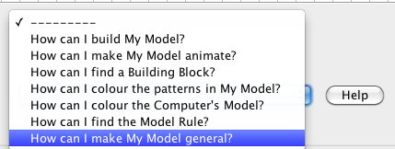
The Intelligent Support messes-up her pattern once more and the message reads: “The system changed this unlocked number again. How can you tell the system a rule for working out this number?”

Not sure what to do, she asks the same help
“Make sure all your patterns are linked. You can use the same unlocked number in several patterns and expressions.“

Step 18 - Laura thinks about the adjustments she was making to the unlocked number in the blue pattern every time. She realises that she is always adding 1 to the unlocked number she would change in the red pattern, so she builds the following expression in the construction area, using the unlocked number of repetitions of her blue pattern.  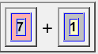  (the value of the unlocked number will be different depending the value that the intelligent support has chosen for the messing-up) | Step 19 - She places this expression on the repetitions placeholder of the red pattern and adjusts the expressions accordingly:  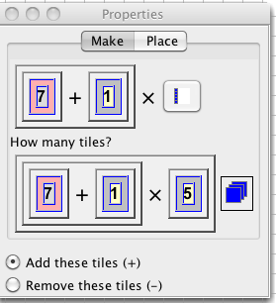
Step 20: She checks her model by manually trying various values and then animates as well. The model does not mess-up any more, but the General Model is still uncoloured.

Step 21 - She composes an expression for the Model Rule, which she places in the model rule area, to colour the General Model.

To finish she names the unlocked number as “model n” to indicate that it represents the model number. That’s her final rule:
